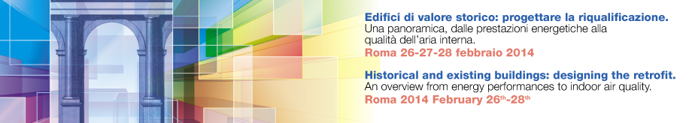

TITLE OF THE CONFERENCE

TITLE OF THE PAPER
Name and Surname of Author and co-authors; affiliation

Text

Template has been reduced due to word program limits; it is therefore necessary to inform your printer on the final printing format which should result in cm 80 x 150

IMPORTANT:
STAY WITHIN MARGINS OF THE WORD DOCUMENT
Avoid too long texts;
Make text as simple as possible while illustrating key concepts;
Minimum text body: Arial 16:
Print: enlarge 300%

